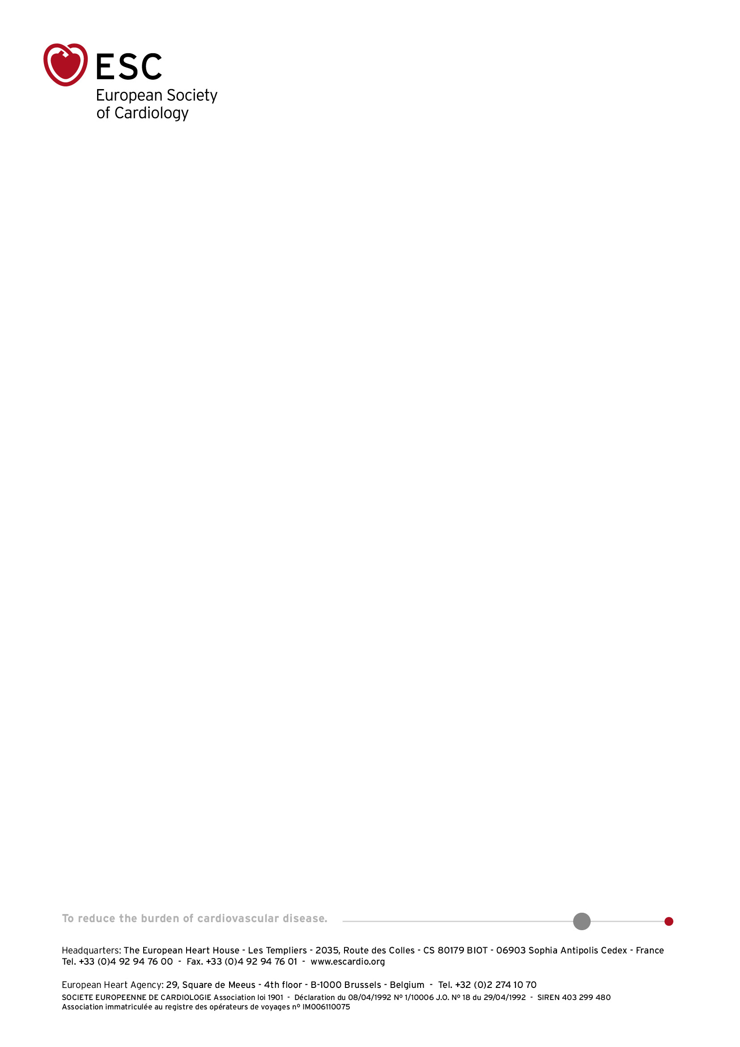

**ESC ELECTIONS 2024**

CANDIDATE CODE OF CONDUCT

**This document describes the Code of Conduct that must be respected by candidates for an elected position on the ESC Board, as well as any other candidate standing for election to the Audit Committee or Nominating Committee of the ESC.**

* Candidates for elected positions on the Audit Committee, ESC Board and Nominating Committee must refrain from canvassing activities, such as travelling to meet Constituent Bodies for reasons unrelated to their current ESC activities, or from mailing / e-mailing Constituent Bodies, other than once to communicate their manifesto.
* Candidates for the position of President-Elect will be invited to present their manifesto at the ESC Spring Summit 2024
* Following the ESC Spring Summit 2024, the CVs and letters of motivation of all candidates will be posted on the elections page of the ESC website.
* At the discretion of the Nominating Committee, the Spring Summit presentation slides of candidates for the position of President-Elect may also be published on the elections page of the ESC website.
* No other form of campaign activity is allowed during the election period, which starts with the official publication of the final slate to the end of the voting period.
* In case of violation on the part of the candidate, the Nominating Committee and the ESC Ethics Committee will examine the evidence and act accordingly. This may include disqualifying the candidate from standing in the election.

Agreed Name : _________________________________________

Signature : ___________________________________

Date: _________________________________________